A Software Toolkit for
SCDS-based Respiratory Motion Estimation
Xiaoxiao Liu
Computer Science Department
UNC-Chapel hill
Software release 0.1
Date: August, 2010

- Introduction

Respiratory motion challenges image-guided radiation therapy (IGRT) with location uncertainties of important anatomical structures in the thorax. Effective and accurate respiration estimation is crucial to account for the motion effects on the radiation dose to tumors and organs at risk.

The shape-correlated deformation statistics (SCDS) motion estimation system is a software toolkit designed for estimating the respiratory motion (dense image deformation fields) from 4D/Respiration-correlated CT images. This software toolkit serves for internal research (MIDAG, UNC) purposes only.

A brief summary of the research project is given as follows. Learning-based linear motion modeling techniques have the advantage that training knowledge can be introduced to reveal the true motion. In this SCDS motion estimation system, shape-correlation deformation statistics (SCDS) captures strong correlations between the shape of the lung and the dense deformation field under breathing. Dimension reduction and linear regression techniques are used to extract the correlation statistics. Based on the assumption that the deformation correlations are consistent between planning and treatment time, patient-specific SCDS trained from a 4D planning image sequence is used to predict the respiratory motion in the patient's artifact-laden 4D treatment image sequence.

Furthermore, the SCDS-prediction results combined with intensity-matching forces are integrated into a prediction-driven atlas formation framework. The strategy of balancing between the prediction constraints and the intensity-matching forces makes the method less sensitive to variation in the correlation and utilizes intensity information besides the lung boundaries. This strategy thus provides improved motion estimation accuracy and robustness.

Details of the application background of the work can be found in Chapter 2 of [1]. Figure 1 illustrates the whole system pipeline, which contains three major components: SCDS training, SCDS prediction and prediction-driven atlas. Each component is briefly described in the following.
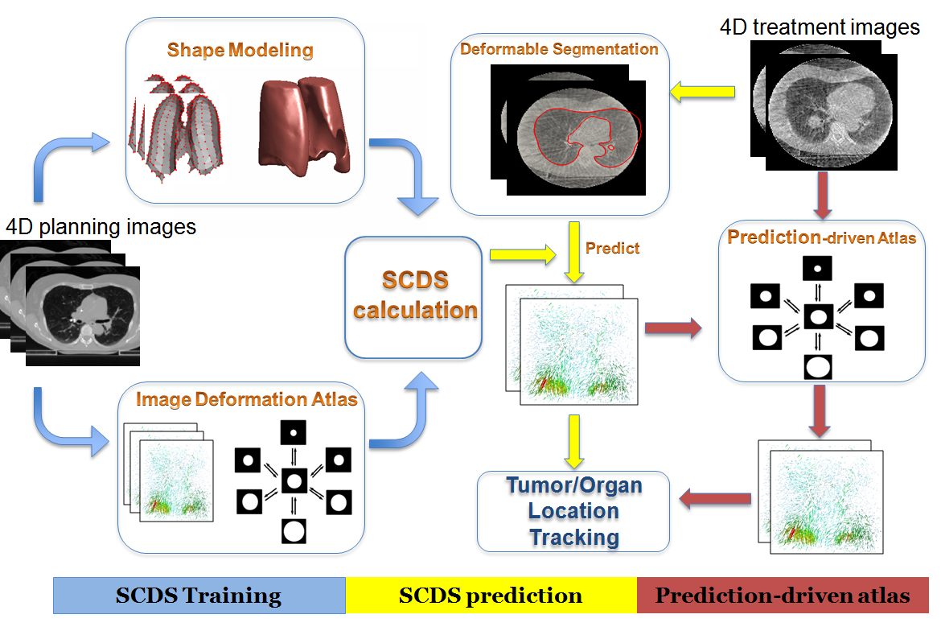
Figure 1. SCDS motion estimation system design pipeline
  - SCDS training
Three modules are needed in computing the SCDS: shape PDM models of the lung extracted from the RCCT images, the image deformation fields extracted from the RCCT images, and the statistical correlation computation. The shape models of the lung are extracted by an entropy-based particle system, which optimizes the group-wise surface correspondence. The image deformation fields are the displacement vector fields calculated from a Fréchet mean atlas formation algorithm. For correlation analysis, PCA is used to reduce the dimensions of the shape variation space and the image deformation space respectively. The linear regression is carried out to calculate the correlation parameters between the shape and the image deformation. For algorithmic details, please refer to Chapter 3 of [1].

  - SCDS prediction
In order to predict the motion from artifact-laden CBCT images, robust shape segmentation is needed. A posterior probability segmentation scheme is used to extract the lung shape from the CBCT images (see Figure 2). After the shape segmentation, the prediction is calculated by a simple linear mapping via the correlation parameters trained from the planning data.

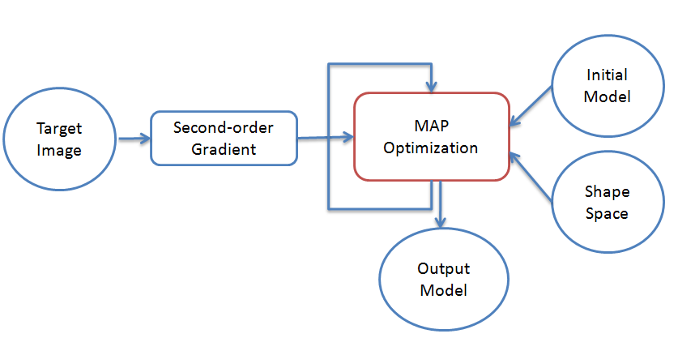
Figure 2. Probabilistic deformable segmentation pipe line

For algorithmic details, please refer to Chapter 4 of [1].

  - Prediction-driven atlas
A Fréchet mean atlas formation with constraints of deformation field prediction is used to obtain robust motion estimation results. Comparing to SCDS prediction, the prediction-driven atlas utilizes more intensity features and thus tends to be less sensitive to inconsistent breathing patterns between the training data and the test data. For algorithmic details, please refer to Chapter 5 of [1].

- Software package repository

Users can check out the package from computer science CVS:
svn+ssh://your userid@cvs.cs.unc.edu/cvs/user/sharonxx/proj/
[Please check http://www.cs.unc.edu/cgi-bin/howto?howto=cvs to learn how to use CVS.
Note: Please refer to “svn.doc” in the root folder for ways of avoiding typing password while using totories SVN in windows.

The following four folders are included in this toolkit:
- /SCDS/ (about 300MB in size) contains C++ codes, probabilistic deformation segmentation and some image processing tools.
- /matlab/ (about 300 function files) contains matlab functions for training SCDS, visualization tools
- /Test scripts/ contains bash scripts and matlab scripts for running all motion estimation experiments
- /Utilities contains c++ codes simple image processing tasks, such as binary segmentation of the lung.

- Program running environment
- C++ codes
  - Suggest to build all C++ programs using cmake .
    - All the C++ programs in the package have been tested on bass , the UNC CS computing cluster, which supports parallel computing for speed. Speed on windows have not be tested yet.
- Required C++ Libraries
  - ITK: The Insight Tookit.
  - VTK: The visualization toolkit.
  - fftw: a C subroutine library for computing the discrete Fourier transform (DFT) .
  - fltk: FLTK (pronounced "fulltick") is a cross-platform C++ GUI toolkit that provides modern GUI functionality without the bloat and supports 3D graphics via OpenGL and its built-in GLUT emulation.
  - LAPACK: The Linear Algebra PACKage.
All of them can be downloaded from the web for free.
- Matlab scripts
  - suggested matlab version: matlab2009a

Note: For testing the programs in bass, there are compiled programs available in “/bass/home/sharonxx/bin”. The corresponding experimental data are stored in “/bass/stage/sharonxx/proj/mskcc”.
More information about how to set up a bass account and run scripts on bass, please refer to http://wwwx.cs.unc.edu/Research/bass/index.php/Bass_Wiki.

- The SCDS system software
This section provides details of the major programs in the SCDS system for carrying out respiratory motion estimation from artifact-laden image sequences. The aforementioned three components are introduced one by one in this section. The overall pipeline is executed through the bash scripts that are introduced in the next section.

  - SCDS training
    - Binary segmentation
To segment air-filled lung regions from the RCCT images, simple binary threshold, followed by the hole-filling operator is sufficient. Three executable are used:

ThresholdImage: Binary threshold.
- Input Parameters: imageDimension inputImageFileName outputImageFileName threshold_min threshold_max
- File Formats: meta image (.mhd)
- Example: ThresholdImage 3 ./gray-inter/cinePhase00.mhd ./binary-inter/lung-bin-cinePhase00.mhd 600 1000
RollingBall: Filling the holes in the segmented regions.
- Input Parameters: inputImageFileName outputImageFileName erodeRadius dilateRadius holeFillingRadius_x holeFillingRadius_y holeFillingRadius_z majorityThreshold maximumIterations
- File Formats: meta image (.mhd)
- Example: RollingBall ./binary-inter/lung-bin-cinePhase00.mhd ./binary-inter/lung-bin-cinePhase00.mhd 0 0 1 1 1 1 25
ConnectedThreshold: extract the connected regions ( with intensity values in the threshold range) originated from the seeds.
- Input Parameters: inputImageFileName outputImageFileName Threshold_min Threshold_max Seed1’s coordinates (x y z) Seed2’ coordinates (x y z)
- File Formats: meta image (.mhd)
- Example: ConnectedThreshold /binary-inter/lung-bin-cinePhase00.mhd ./binary-inter/lung-bin-cinePhase00.mhd 1 2 100 200 300 200 100 300

The source codes of the segmentation programs are located in the “Utility” folder.
    - Shape modeling using entropy-based particle system
The entropy-based particle system generates point distribution models (PDMs) from a set of input binary images. The ordered point sets, so called particles, have optimized group-wise surface correspondence [2]. The binary segmentation results (4.1.1) are the input of the entropy-based particle system.

The entropy-based particle system is an on-going project originated in SCI of University of Utah, the software package “ShapeWorks” is available for research usage at:
https://gforge.sci.utah.edu/gf/project/shapeworks/.

Among the executables, ShapeWorksGroom is for preprocessing purposes and ShapeWorksRun is for running the particle optimization. ShapeWorksShop is a GUI-version of the ShapeWorksRun. GUI-version (enabled user interactions) of the particle system is preferred for better supervision of the optimization process. However, ShapeWorksShop is still under development and with limited support at this moment.

In UNC, Oguz [3] of Computer Science Dept is leading a research team on applying the entropy-based particle system to various anatomical structures in different medical image analysis problems. The executables used in this research projects are provided by the UNC group with additional functionalities (comparing to ShapeWorks). Their usages are introduced as follows.

CropAndPad: This is a preprocessing step to crop the input images for more efficient optimization and pad the edges of the image to avoid open surfaces (there is often a cut-off along z axis in lung images due to the limited field-of-view).
- Input Parameters: inputImageFileName outputImageFileName croppingOrigin ( x y z) croppingSize (in x y z) paddingSize( x y z)
- Example: CropAndPad rcctImageFolder/binary-inter/lung-bin-cinePhase00.mhd shapeFolder/lung-bin-crop-pad-cinePhase0i.mhd 0 0 0 100 100 100 8 8 8

Correspondence: GUI-version of the particle optimization program, which serves the same purpose of the ShapeWorksShop but with better stability.
- Input Parameters: parameterFileName
- Example: Correspondence particle.params
- Format of the parameter file: An example is given as follows.
(output_points_prefix "points")
(inputs
"../lung-bin-cinePhase00.dis.mhd"
"../lung-bin-cinePhase10.dis.mhd"
…
)
(point_files "../seeds.lpts" "../seeds.lpts" …)
(outputs "/dev/null")
(attributes_per_domain 0)
(antialias_iterations 40)
(fastmarching_isovalue 0.0)

- Note: For lung models, it is better to initialize the optimization with two seed points that are located on the left and the right lung separately (use matlab script writeSeed.m) . To get satisfactory correspondence condition, it is usually helpful to turn the weight on the correspondence entropy higher than the surface entropy.

    - Motion atlas formation
Fréchet mean formation method is used to generate the motion atlas from RCCT images [4].

AtlasWerks: This program generates the Fréchet mean image and all the deformations that transform each individual input image to that Fréchet mean image. Muti-resolution schemes are used to speed up the computation. Also the program itself is a multithreaded implementation.
- Input Parameters:
AtlasWerks [OPTION]... image0 image1... [transform0] [transform1] [...]
Options:
-h, --help show this help
-v, --verbose verbose output
-I, --incompressible compute incompressible flows
-o, --outputImageFilenamePrefix=PREFIX image filename prefix
-o, --outputDeformedImageFilenamePrefix=PREFIX deformedimage filename prefix
-f, --outputHFieldFilenamePrefix=PREFIX hfield filename prefix
-p, --outputHInvFieldFilenamePrefix=PREFIX inverse hfield filename prefix
-n, --intensityWindowMin=VAL intensity window min value
-x, --intensityWindowMax=VAL intensity window max value
-s, --scaleLevel=SCALE add scale level (1,2,4,...)

Algorithm parameters for the current scale level:
--alpha=VAL
--beta=VAL
--gamma=VAL
--maxPerturbation=VAL
-i, --numberOfIterations=VAL

- Example: AtlasWorks
--outputImageFilenamePrefix=averageImage_
--outputDeformedImageFilenamePrefix=deformedImage_
--outputHFieldFilenamePrefix=deformationField_
--scaleLevel=4 --numberOfIterations=100
--scaleLevel=2 --numberOfIterations=50
--scaleLevel=1 --numberOfIterations=25
allMyImages*mhd

    - Linear regression
The SCDS includes the variation spaces of the lung shape and the dense image deformation field, and the correlations between the two spaces. The variation spaces are extracted via PCA. The correlation is carried out through multivariate linear regression techniques. The matlab implementation is introduced as follows.
trainSCDS: In this function, PCA analysis on both the shape variations and the dense displacement vector fields are carried out first (trainMeshPts and trainHField). And then the linear regression is used to compute the correlation matrix (CCA is used).

trainMeshPtsStats: This script is for visualize the shape variation space with animations of surfaces, point sets or wireframes in breathing motion.

  - SCDS prediction

    - Probabilistic deformable model segmentation
In order to predict the motion from CBCTs, the lung shapes from the CBCT images need to be extracted first. To count for the image artifacts of CBCT, the probabilistic deformation model segmentation is used.

pDeform: This program implements a maximum-a-posteriori optimization scheme that is used for segment lung shape from artifact-laden CBCT images.
- Input Parameters: -h, --help show help info
-v, --verbose verbose output
-pcaStats, shape statistics file name
-refMesh, mesh file name [if mesh model is used]
-image, image file name
-output, output model file name
-numIters, maximum of iterations: default 100
-weightShapePrior, weight of shape prior: default 100.0 [weight of the image match is 1.0]
-numPCs, number of PCs: default 3
-stepSizeD, step size for calculating derivative during optimization: default 0.1
-gaussSigma, gaussian sigma for calculating image gradient feature: default 7

- Example: pDeform -v -numPCs 3 -weightShapePrior 0.1 -numIters 25 -stepSizeD 0.2 -gaussSigma 7 –image /cbct/image/gray-inter/phase00.mhd -pcaStats /rcct/stats/PtsStats-xyz/PtsStats.txt –output /cbct/segmentation/xyz/fit.0.lpts

The training process and the prediction step are wrapped up in a single script file: run_predict_inter.m.

  - Prediction-driven atlas
scdsWarp: This program carries out the prediction-driven atlas formation optimization. The SCDS prediction results are parts of the input of this program. Similar to the intensity-based Fréchet mean formation program, the optimization uses multi-scale strategy and is implemented with multi-threads.
- Input Parameters:
-h, --help show this help
-v, --verbose verbose output
-I, --incompressible compute incompressible flows
--numberOfImages=VAL number of input images
--initWithInputHField=BOOL default true
--inputImageList image0 image1 ... list of image file names
--inputHFieldList hfield0 hfield1.. list of hfield file names
--inputCompHFieldList hfield0 hfield1.. list of groud truth (for comparison) hfield file names
--optWeights <w1> <w2> ... weights for body forces of image intensity and prediced Hfields
--shapeScores <w1> <w2> ... surrogate shapeScores for each image
-o, --outputImageFilenamePrefix=PREFIX image filename prefix
-o, --outputDeformedImageFilenamePrefix=PREFIX deformedimage filename prefix
-f, --outputHFieldFilenamePrefix=PREFIX hfield filename prefix
-p, --outputHInvFieldFilenamePrefix=PREFIX inverse hfield filename prefix
-n, --intensityWindowMin=VAL intensity window min value
-x, --intensityWindowMax=VAL intensity window max value
-s, --scaleLevel=SCALE add scale level (1,2,4,...)
Algorithm parameters for the current scale level:
--alpha=VAL
--beta=VAL
--gamma=VAL
--maxPerturbation=VAL
-i, --numberOfIterations=VAL
- Example: scdsWarp \
--numberOfImages 2 \
--inputImageList image0.mhd image1.mhd \
--inputHFieldList hfield0.mhd hfield1.mhd \
--inputCompHFieldList gt_hfield0.mhd gt_hfield1.mhd \
--outputImageFilenamePrefix=averageImage_ \
--outputDeformedImageFilenamePrefix=deformedImage_ \
--outputHFieldFilenamePrefix=deformationField_ \
--scaleLevel=4 --numberOfIterations=100 \
--scaleLevel=2 --numberOfIterations=50 \
--scaleLevel=1 --numberOfIterations=25

- Test scripts (including evaluation)
This section introduces the bash scripts used for running the motion estimation experiment as a whole pipeline. An example of carrying out the motion estimation from CBCT images is given below with detailed comments.

# A bash script example for SCDS-based respiratory motion estimation.
# Programs are running on bass.cs.unc.edu
# Xiaoxiao Liu
# April, 2010
###################### parameters setting ########################
patNo=113;
# set threshold, seeds, crop parameters
pat$patNo.params.bash
spacing=(1.52 1.52 1.52) # CBCT's image spacing for re-sampling purpose

# default data storgage
scriptsFolder=~sharonxx/scripts/SCDS-cbct/patient
dataFolder=/stage/sharonxx/proj/mskcc/Patient$patNo
cbctFolder=$dataFolder/cbct
cbctImageFolder=$dataFolder/cbct/image

rcctFolder=$dataFolder/rcct
rcctImageFolder=$dataFolder/rcct/image
rcctAtlasFolder=$dataFolder/rcct/atlas
shapeFolder=$dataFolder/rcct/shape
statsFolder=$dataFolder/rcct/stats

resultsFolder=$dataFolder/results
scdsPredictionFolder=$dataFolder/results/SCDS_predict
scdsWarpFolder=$dataFolder/results/SCDS_warp
origDICOMImageFolder=$dataFolder/pt$patNo/cbct1

################## Align RRCT with CBCT ########################
#1. Resampling
for i in 0 1 2 3 4 5 6 7 8 9 ;
do ResampleImageBySpacing 3 $rcctImageFolder/gray/cinePhase$i\0.mhd $rcctImageFolder/gray/cinePhase$i\0.mhd ${spacing[0]} ${spacing[1]} ${spacing[2]};
done

#2. Find out intersection using
$scriptsFolder/intersectionRegionExtract_RCCT_CBCT.m

############## Binary Segmentation #############################
cd $rcctImageFolder
mkdir binary-inter
for i in 00 10 20 30 40 50 60 70 80 90
do
ThresholdImage 3 ./gray-inter/cinePhase$i.mhd ./binary-inter/lung-bin-cinePhase$i.mhd ${threshold[0]} ${threshold[1]}
RollingBall ./binary-inter/lung-bin-cinePhase$i.mhd ./binary-inter/lung-bin-cinePhase$i.mhd 0 0 1 1 1 1 25
ConnectedThreshold ./binary-inter/lung-bin-cinePhase$i.mhd ./binary-inter/lung-bin-cinePhase$i.mhd 1 2 ${seed[0]} ${seed[1]} ${seed[2]} ${seed[3]} ${seed[4]} ${seed[5]}
done

## a sanity check of the segmentation results by looking at the middle slices of all segmentations
#StackSlices StackBinarySegMidSlice.mhd -1 -1 35 binary-inter/*.mhd

############## Shape Modeling with particle systems ########################
#1. Crop the binary image and pad the boundaries
for i in 00 10 20 30 40 50 60 70 80 90 ;
do CropAndPad $rcctImageFolder/binary-inter/lung-bin-cinePhase$i.mhd $shapeFolder/lung-bin-crop-pad-cinePhase$i.mhd ${crop[0]} ${crop[1]} ${crop[2]} ${crop[3]} ${crop[4]} ${crop[5]} 8 8 8 ;
done
# remove small objects
for i in 00 10 20 30 40 50 60 70 80 90; do BinaryErode $shapeFolder/lung-bin-crop-pad-cinePhase$i.mhd $shapeFolder/lung-bin-crop-pad-cinePhase$i.mhd 2; BinaryDilate $shapeFolder/lung-bin-crop-pad-cinePhase$i.mhd $shapeFolder/lung-bin-crop-pad-cinePhase$i.mhd 2;done

#2. Generate distance map for correspondence
qsub $scriptsFolder/distancemap_qsub.bash $patNo

#3. Interactively run correspondence
#write seeds file
$scriptsFolder/writeSeeds.m
mkdir $shapeFolder/xyz
cd $shapeFolder/xyz
cp $scriptsFolder/particle.XYZ.params ./particle.params
Correspondence particle.params

#running without GUI
#cp $scriptsFolder/shapeWorksRun.params ./
#ShapeWorksRun ./shapeWorksRun.params
qsub $scriptsFolder/vol2surf.bash $patNo 15

# generate the meshes from the original binary volume
qsub $scriptsFolder/vol2surf.bash $patNo 5

#post processing to get the meshes from the correpsonding point sets
cp $scriptsFolder/corresMesh.params $shapeFolder/xyz
cd $shapeFolder/xyz
/home/ipek/NeuroLib-build/bin/ParticleCorrespondencePostprocessingTPS --parameterFileName corresMesh.params
$scriptsFolder/trainMeshStats.m # train the mesh shape models

############## Probabilistic Deformable Model Segmentation ###########
mkdir $cbctFolder/segmentation
mkdir $cbctFolder/segmentation/xyz
qsub $scriptsFolder/meshDeform-CBCT.bash $patNo # segment CBCT

############## Training atlas on CBCT ########################
qsub $scriptsFolder/atlasWerks.bash Patient$patNo

############### predict CBCT displacement vector fields########################
$scriptsFolder/run_predict_inter.m

#To generate the atlas image, apply the predicted deformation.
mkdir $resultsFolder/SCDS_predict
mkdir $resultsFolder/SCDS_predict/deformedImage
cd $resultsFolder/SCDS_predict/deformedImage
for n in 00 16 32 50 66 82
do txApply -b -i $cbctFolder/image/gray-inter/phase$n.mhd -h $resultsFolder/SCDS_predict/Hfield/pred-hfield-phase$n.mhd -o deformedPhase$n
done

# get the Euclidean mean
AtlasWerks --outputImageFilenamePrefix=averageImage_ --scaleLevel=1 --numberOfIterations=0 *.mhd

############# Fréchet mean ########################
qsub $scriptsFolder/scdsWarp.bash Patient$patNo

############### Evaluation ######################
# Evaluate the prediction accuracy on a tumor region or ROI.
evaluateROI.bash

Reference
[1] Xiaoxiao Liu, Shape-correlated Statistical Modeling and Analysis for Respiratory Motion Estimation, PhD thesis, UNC-CH, 2010
[2] J. Cates, P. Flectcher, and R. Whitaker. Entropy-based particle systems for shape correspondence. In Mathematical Foundations of Computational Anatomy workshop, pages 170-181, MICCAI 2008
[3] Ipek Oguz, Groupwise Shape Correspondence with Local Features, PhD thesis, UNC-CH, 2009
[4] Bradely Davis, Medical Image Analysis via Fréchet Means of Diffeomorphisms, PhD thesis, UNC-CH, 2008

